Learning Path We'll Follow
Python Application
↓
Run Locally
↓
Understand Dockerfile
↓
Build Docker Image Locally
↓
Run Container Locally
↓
Push Code to Azure Repo
↓
Classic Build Pipeline
↓
Push Image to ACR
↓
Deploy to AKS
↓
Helm Deployment

- Replace versions
- Update requirements.txt
Replace -
Flask==2.0.3
Werkzeug==2.0.3

Open Dockerfile
Replace-
FROM python:3.14-alpine

- Go to the project folder on powershell.
Create Virtual Environment using below command.
- python -m venv venv

- Install Dependencies.
- pip install -r requirements.txt

- test run Application using python
- python app.py
check on browser
- http://localhost:5000

- Build Docker Image
- docker build -t flaskcat:v1 .
- docker images

- Run Docker Container
- docker run -d -p 5000:5000 --name flaskcat1 flaskcat:v1
- docker ps
- docker logs flaskcat1
- http://localhost:5000

- Enter the Container(For knowledge optional)
- docker exec -it flaskcat1 sh
- exit
- Check Container Resource Usage
- docker stats flaskcat1
- Push Code to Azure Repos
- git init
git add .
git commit -m "Initial Flask Docker App"
Now code is stored on Azure repo, we will first create Azure Container Registry and will store our docker image there before building the build pipeline.
- Create ACR
- Create ACR Service Connection
Project Settings Service Connections New Service Connection Docker Registry Azure Container Registry Service Principle Enter other fields.

- Create Classic Build Pipeline
Pipelines Build Pipelines New Pipeline Use Classic Editor Empty Job Add Task Docker Enter other details command – buildandpush

Once the build succeeded check if new repo is created in ACR and check tags for images created. Note, in this step there will be no artifact created yet.

- Create a folder k8s in your repo(To pass deployment.yaml and service.yaml to release pipeline as artifact)

Open deployment.yaml and paste below-

apiVersion: apps/v1
kind: Deployment
metadata:
name: my-python-deployment
spec:
replicas: 2
selector:
matchLabels:
app: python-app
template:
metadata:
labels:
app: python-app
spec:
containers:
- name: newpythonrepo
image: dockerregisty.azurecr.io/newpythonrepo:latest
imagePullPolicy: Always
ports:
- containerPort: 5000

Open service.yaml and paste below-

apiVersion: v1
kind: Service

metadata:
name: flaskcat-service

spec:
type: LoadBalancer

selector:
app: flaskcat

ports:
- port: 80
targetPort: 5000

- Git add, commit and push the updated code to azure repo. Create pull request if not updated to main.
- Modify Build Pipeline Add task: Copy Files
Source Folder:
$(Build.SourcesDirectory)
Contents:
k8s/**
Target Folder:
$(Build.ArtifactStagingDirectory)

- add task: Publish build artifact
Path to publish:
$(Build.ArtifactStagingDirectory)
Artifact Name:
manifests

- Now build stage is completed and artifact is generated. We will create AKS cluster now.

- Create Kubernetes cluster and enter the details, keep the default settings. Most important, select Container Registry on integration tab.
On Node Pools select disk “Standard_B2s” if doesn’t work then “DS2_v2”.

- Create AKS Service Connection
Project Settings Service Connections New Service Connection Kubernetes Choose AKS Cluster Save

- Create Release Pipeline
Pipelines Releases New Release Pipeline Empty Job Add Artifact Add task “Deploy to Kubernetes”
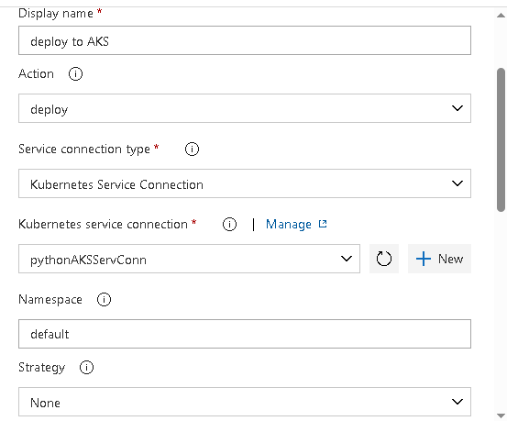
- Once release succeeded go to AKS Kubernetes Resources Services and ingress Check for type “Load Balancer” click on “External IP”

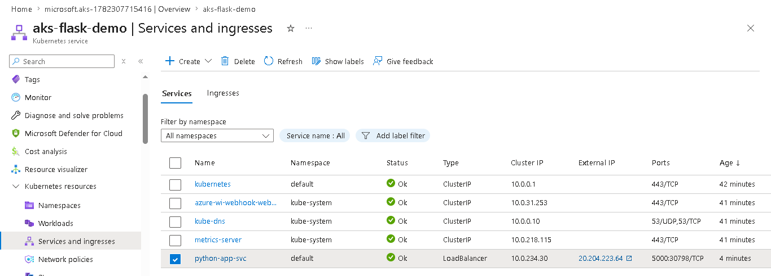

If all good you should see below image
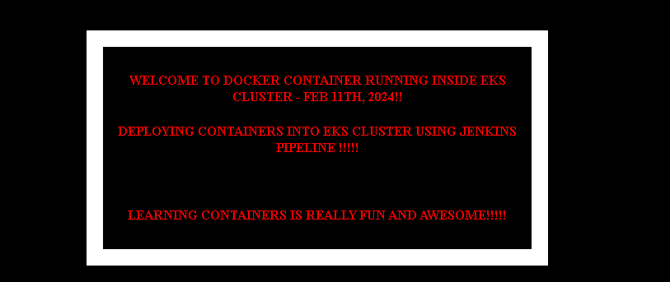

Interview questions-
Q . Difference between Deployment and Service?
Answer:
Deployment:
Manages Pods
Service:
Exposes Pods to network traffic

Q. What causes ImagePullBackOff?
You can answer from experience:
1. Wrong image tag
2. Wrong repository name
3. AKS not attached to ACR
4. ACR permission issue

This above approach is good only for small applications or tests, in realtime environment Helm chart is widely used.

Now lets start deploying with Helm chart:-
This is how workflow will look like in realtime
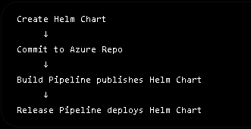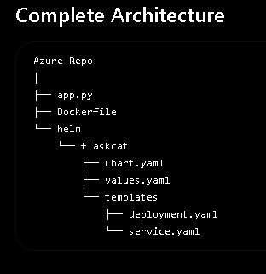

- Install Helm
- On Powershell
winget install Helm.Helm
helm version

- Create a New Helm Chart
Go to project folder
- helm create mychart
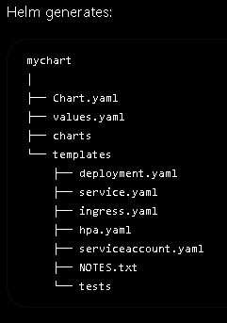

- Edit Chart.yaml
Open chart.yaml and put below

apiVersion: v2
name: flaskcat
description: Helm chart for Flask Cat Application
type: application

version: 0.1.0
appVersion: "394"

- Edit values.yaml and put below (All environment-specific values go here.)

replicaCount: 2
image:
repository: dockerregisty.azurecr.io/flaskcat
tag: "394"
pullPolicy: Always
service:
type: LoadBalancer
port: 5000

- Edit deployment.yaml

apiVersion: apps/v1
kind: Deployment

metadata:
name: {{ .Release.Name }}-deployment

spec:
replicas: {{ .Values.replicaCount }}

selector:
matchLabels:
app: {{ .Release.Name }}

template:
metadata:
labels:
app: {{ .Release.Name }}

spec:
containers:
- name: flaskcat

image: "{{ .Values.image.repository }}:{{ .Values.image.tag }}"

imagePullPolicy: {{ .Values.image.pullPolicy }}

ports:
- containerPort: {{ .Values.service.port }}

- Edit service.yaml
apiVersion: v1
kind: Service

metadata:
name: {{ .Release.Name }}-service

spec:
type: {{ .Values.service.type }}

selector:
app: {{ .Release.Name }}

ports:
- port: 80
targetPort: {{ .Values.service.port }}

- Validate chart locally
helm lint .\mychart

- Generate Kubernetes YAML
helm template flaskcat .\mychart

// This creates a plan just like we create in Terraform plan.

- Commit to Azure repo
git add mychart
git commit -m "Added Helm chart for Flask application"
git push

- Edit the build pipeline
Add “Copy files” task and put below
Source Folder:
$(Build.SourcesDirectory)
Contents:
mychart/**

Target
$(Build.ArtifactStagingDirectory)

Add “Publish Build artifact” task and put below
Artifact Name:
helm-chart

Now once the build is succeeded , we will create release pipeline

- Add task Helm deploy, and put all the details
- Namespace as ‘default’
- Command as ‘upgrade’
This internally runs:
helm upgrade –install
which means:
If release exists → Upgrade
If not → Install

- The biggest advantage using helm is easy rollback
- Suppose build 395 breaks:
helm history flaskcat
O/P: REVISION STATUS
1 deployed
2 deployed
- Rollback:
helm rollback flaskcat 1

